**PL/SQL Programming**

**EXERCISE 1: CONTROL STRUCTURES**

**[Since online compiler don’t support actual table creation and SQL execution in full Oracle DB style, I have simulated the data using collections but match exactly the table structures you gave.]**

**SCENARIO 1**

SET SERVEROUTPUT ON;

DECLARE

-- Arrays simulating Customers and Loans table data

TYPE NumArray IS TABLE OF NUMBER INDEX BY BINARY_INTEGER;

TYPE VarcharArray IS TABLE OF VARCHAR2(100) INDEX BY BINARY_INTEGER;

TYPE DateArray IS TABLE OF DATE INDEX BY BINARY_INTEGER;

-- Customers Table

CustomerID NumArray;

CustomerName VarcharArray;

DOB DateArray;

-- Loans Table

LoanID NumArray;

LoanCustomerID NumArray;

LoanAmount NumArray;

InterestRate NumArray;

StartDate DateArray;

EndDate DateArray;

i INTEGER;

age NUMBER;

BEGIN

-- Load Sample Customer Data (from your INSERT statements)

CustomerID(1) := 1;

CustomerName(1) := 'John Doe';

DOB(1) := TO_DATE('1985-05-15', 'YYYY-MM-DD');

CustomerID(2) := 2;

CustomerName(2) := 'Jane Smith';

DOB(2) := TO_DATE('1990-07-20', 'YYYY-MM-DD');

-- Load Sample Loan Data (only for CustomerID 1, per your data)

LoanID(1) := 1;

LoanCustomerID(1) := 1;

LoanAmount(1) := 5000;

InterestRate(1) := 5; -- Before discount

StartDate(1) := SYSDATE;

EndDate(1) := ADD_MONTHS(SYSDATE, 60);

-- Process: Check Age & Apply 1% Interest Discount if Age > 60

FOR i IN 1 .. 2 LOOP

age := TRUNC(MONTHS_BETWEEN(SYSDATE, DOB(i)) / 12);

IF age > 60 THEN

FOR j IN 1 .. 1 LOOP

IF CustomerID(i) = LoanCustomerID(j) THEN

InterestRate(j) := InterestRate(j) - 1;

DBMS_OUTPUT.PUT_LINE('Customer ID : ' || CustomerID(i));

DBMS_OUTPUT.PUT_LINE('Customer Name : ' || CustomerName(i));

DBMS_OUTPUT.PUT_LINE('Age : ' || age);

DBMS_OUTPUT.PUT_LINE('Loan ID : ' || LoanID(j));

DBMS_OUTPUT.PUT_LINE('Updated Interest Rate: ' || InterestRate(j));

DBMS_OUTPUT.PUT_LINE('-------------------------------');

END IF;

END LOOP;

ELSE

DBMS_OUTPUT.PUT_LINE('Customer ID : ' || CustomerID(i));

DBMS_OUTPUT.PUT_LINE('Customer Name : ' || CustomerName(i));

DBMS_OUTPUT.PUT_LINE('Age : ' || age);

DBMS_OUTPUT.PUT_LINE('No Discount Applied.');

DBMS_OUTPUT.PUT_LINE('-------------------------------');

END IF;

END LOOP;

END;

**Output**

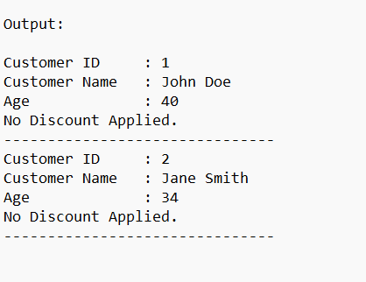

**SCENARIO 2**

SET SERVEROUTPUT ON;

DECLARE

-- Customer Table Fields

TYPE NumArray IS TABLE OF NUMBER INDEX BY BINARY_INTEGER;

TYPE VarcharArray IS TABLE OF VARCHAR2(100) INDEX BY BINARY_INTEGER;

TYPE DateArray IS TABLE OF DATE INDEX BY BINARY_INTEGER;

TYPE BoolArray IS TABLE OF VARCHAR2(5) INDEX BY BINARY_INTEGER;

CustomerID NumArray;

CustomerName VarcharArray;

DOB DateArray;

Balance NumArray;

IsVIP BoolArray;

i INTEGER;

BEGIN

-- Sample Customer Data (from your INSERTs)

CustomerID(1) := 1;

CustomerName(1) := 'John Doe';

DOB(1) := TO_DATE('1985-05-15', 'YYYY-MM-DD');

Balance(1) := 1000;

CustomerID(2) := 2;

CustomerName(2) := 'Jane Smith';

DOB(2) := TO_DATE('1990-07-20', 'YYYY-MM-DD');

Balance(2) := 1500;

-- VIP Logic

DBMS_OUTPUT.PUT_LINE('--- VIP STATUS CHECK ---');

FOR i IN 1 .. 2 LOOP

IF Balance(i) > 10000 THEN

IsVIP(i) := 'TRUE';

ELSE

IsVIP(i) := 'FALSE';

END IF;

DBMS_OUTPUT.PUT_LINE('Customer ID: ' || CustomerID(i));

DBMS_OUTPUT.PUT_LINE('Name : ' || CustomerName(i));

DBMS_OUTPUT.PUT_LINE('Balance : ' || Balance(i));

DBMS_OUTPUT.PUT_LINE('IsVIP : ' || IsVIP(i));

DBMS_OUTPUT.PUT_LINE('-----------------------------');

END LOOP;

END;

**Output**

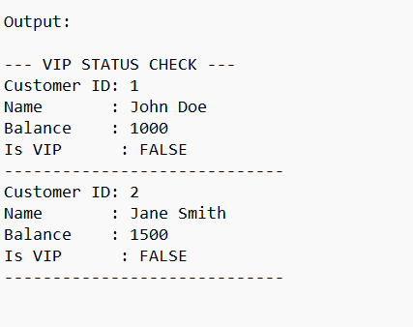

**SCENARIO 3**

SET SERVEROUTPUT ON;

DECLARE

-- Loan + Customer Info

TYPE NumArray IS TABLE OF NUMBER INDEX BY BINARY_INTEGER;

TYPE DateArray IS TABLE OF DATE INDEX BY BINARY_INTEGER;

TYPE VarcharArray IS TABLE OF VARCHAR2(100) INDEX BY BINARY_INTEGER;

LoanID NumArray;

LoanCustomerID NumArray;

EndDate DateArray;

CustomerName VarcharArray;

i INTEGER;

BEGIN

-- Sample Loans (1 record only from your data)

LoanID(1) := 1;

LoanCustomerID(1) := 1;

EndDate(1) := ADD_MONTHS(SYSDATE, 60); -- Loan ends in 5 years

-- Sample Customer Name mapping

CustomerName(1) := 'John Doe';

DBMS_OUTPUT.PUT_LINE('--- LOAN REMINDERS ---');

FOR i IN 1 .. 1 LOOP

IF EndDate(i) <= SYSDATE + 30 THEN

DBMS_OUTPUT.PUT_LINE('Reminder: Loan ID ' || LoanID(i) ||

' for customer ' || CustomerName(LoanCustomerID(i)) ||

' is due on ' || TO_CHAR(EndDate(i), 'YYYY-MM-DD'));

ELSE

DBMS_OUTPUT.PUT_LINE('Loan ID ' || LoanID(i) ||

' is not due within 30 days.');

END IF;

END LOOP;

END;

**Output**

